2a. CLASSIFICATION USING NAIVE BAYES CLASSIFIER (GAUSSIAN, MULTINOMIAL, BERNOULLI) ON LOAD_IRIS DATASET

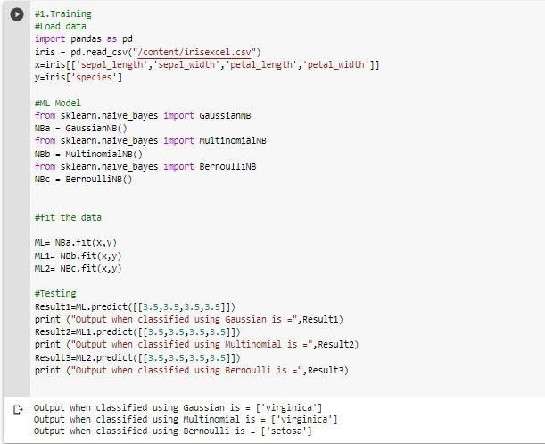

2b. CLASSIFICATION USING NAIVE BAYES CLASSIFIER (GAUSSIAN, MULTINOMIAL, BERNOULLI) ON KAGGLE DATASET (AIRLINE PASSENGERS)

